POMnet MANUAL

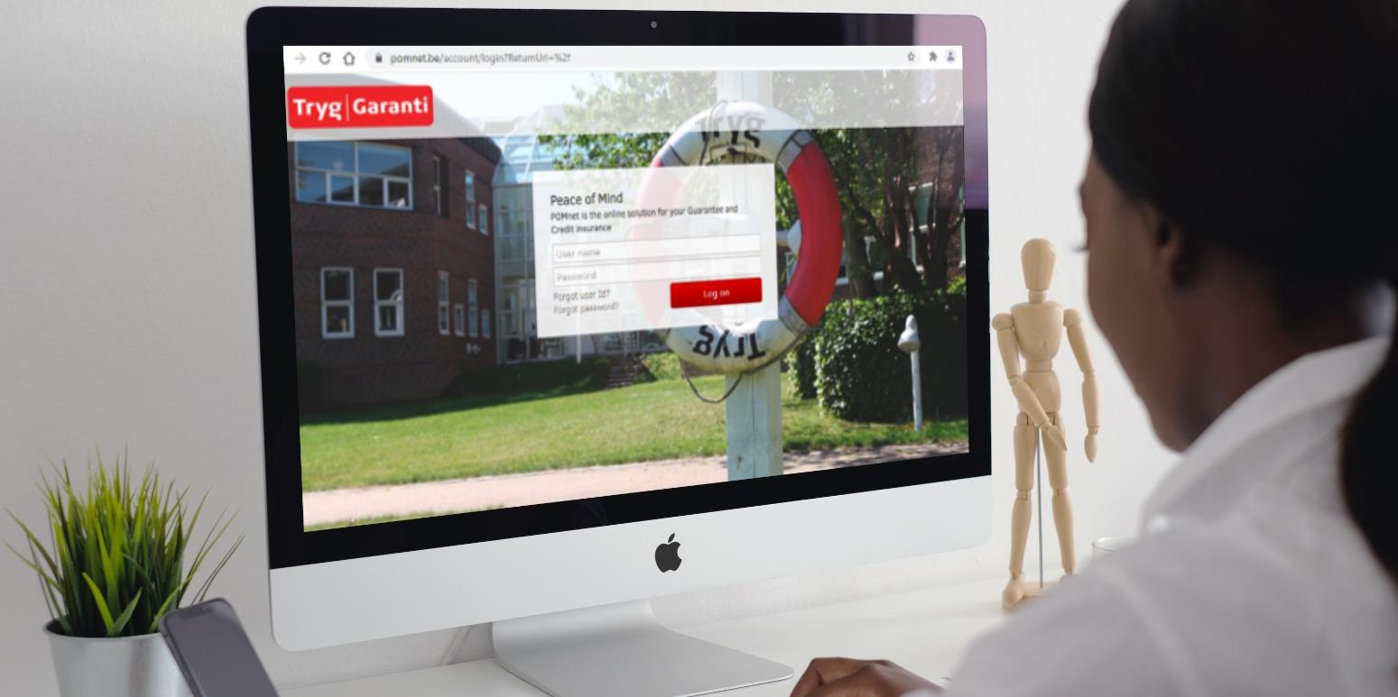

 **LOGIN HOME PAGE**

**REQUEST WARRANTY**

*Please note: It is the clients responsibility to manage their POMnet user access. Information provided on POMnet is confidential and is intended solely for the use of the intended recipient. Please contact your Tryg Garanti representative if you have any queries.*



Beaumont City Tower, 40 Basinghall St, London EC2V 5DE

[post@tryggaranti.uk](mailto:post@tryggaranti.uk)

[**Link to POMnet**](https://pomnet.be/account/login?ReturnUrl=%2fFrontPage%2fIndex)



**LOGIN**

**[Click here for the](https://pomnet.be/account/login?ReturnUrl=%2fFrontPage%2fIndex)**

[**link to POMnet**](https://pomnet.be/account/login?ReturnUrl=%2fFrontPage%2fIndex)

Of via [https://pomnet.uk/Account/Login/](%20https://pomnet.uk/Account/Login/)

# Enter the username and password you received by e-mail

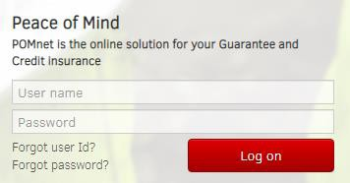

Contact us [here](mailto:post@tryggaranti.uk) if you have forgotten this information



**HOME**



**See next page**



Consult and download monthly overviews of active warranties and quarterly billing

Need rates and the guarantee facility limit? Find them under "Contracts"

The use and availability of the guarantee facility is kept up-to-date here

You can review the current guarantees here. Please note: You can make changes

to the bond or release the bond by sending us an e-mail.

Communicating with us at Tryg Garanti can be done digitally

+

Ankle of Filled with one red * be obligatory in too fill

Select the desired type of bond. If in doubt please contact us

Use the dropdown to choose the correct entity that applies to the bond



**REQUEST WARRANTY**

Fill in the details of the beneficiary

**Tip**: use the automated search and all fields are automatically filled in

How? Fill in the Organization number and click on "Company Search"



Click on the "play" icon to change the expected date to a fixed date.

Please note: the dates will be included in the bond text

The estimated date of final completion of the works

The estimated date of provisional acceptance of the works

Please ensure the currency is correct

The bond value is often 5 or 10% of the contract amount

Enter the total contract value

Click on "view concept guarantee " to view the draft of the text with the

check the data you have entered

Adjustments to the fields are always possible and the draft will be filled in again after these changes

**Please note**: the type of warranty cannot be changed

In case of a wrong choice: contact Safe Guaranteed or share this on

page 2 under 'remarks'



SUBMIT OR SAVE APPLICATION

The request can be saved in draft at any time via the "save draft" button. The concept can then be found under "Portfolio" on the homepage.

If all data is correct: click on the red button "order" and we will process your request within 24 hours.

You will receive the issued bond by e-mail with a link to POMnet where you can download the bond.

Only at your request will Tryg Garanti send this guarantee to the beneficiary by e-mail.

Click on "view concept guarantee " to view the draft of the text with the

check the data you have entered

Adjustments to the fields are always possible and the draft will be filled in again after these changes

**Please note**: the type of bond cannot be changed

In case of a wrong choice: contact us or share this on

page 2 under 'remarks'